Employee Self Service User Guide
  - April 2018

Contents

1.0 Introduction 3
1.1 Logging in to Self Service 3
1.2 The Homepage and Menus 4
1.3 Information Cards 5
1.4 Password and Memorable Information 7
2.0 Main Menu Item: Personal 8
2.1 Reviewing your personal details 8
2.2 Updating your Contact Information 9
2.3 Updating your Bank Details 10
2.4 Adding Private Vehicle Details 11
3.0 Main Menu Item: Absence 12
3.1 Reviewing your Holiday Balances 12
3.2 Looking at your calendar 13
3.3 Looking at the calendar of your colleagues 14
3.4 Adding a new holiday 15
3.4.1 Requesting a single day’s holiday 16
3.4.2 Requesting more than one day’s holiday 17
3.4.3 Requesting part of a day as holiday 18
3.5 Cancelling a Holiday 19
4.0 Main Menu Item: Pay & Benefits 20
4.1 How to view and download your Payslip 20
4.2 How to download a PDF copy of your P60 22
4.3 How to change the email address and / or password that your payslip and / or P60 is emailed to 23
4.4 How to add a new Expenses Claim 24
4.4.1 Creating a new expenses claim 25
4.4.3 Entering Mileage 26
4.4.3 Entering other expenses 27
4.4.4 Adding Personal Journeys to Self Service 28
4.4.5 Saving a claim 30
4.4.6 Submitting your claim 30
4.4.7 Reviewing your claims 31
4.4.8 Authorisation 31
5.0 Main Menu Item: Employment 32
5.1 How to review your employment details 32
6.0 Main Menu Item: Career & Development 33
6.1 How to review the training we have recorded against you 33

1.0 Introduction

1.1 Logging in to Self Service

If you are a Positive Futures ICT user, you will find a link to Self Service on your PF Links drop down menu as below:
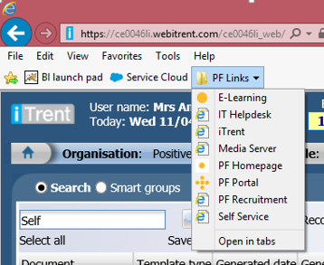

If you are accessing Self Service at home or on your mobile device, type in the following address selfservice.positive-futures.net

You will also find the address for Self Service on the back of your Positive Futures ID card.

Another way to log in is to go to Positive Futures website ‘Useful Links’ area and click iTrent Self Service.

Enter the login details that have been supplied to you. If you do not have these details please log an iTrent Assist (if you are a Positive Futures ICT user) or contact Head Office.

1.2 The Homepage and Menus

When you have logged in, you will be taken to the Self Service homepage which looks like this:

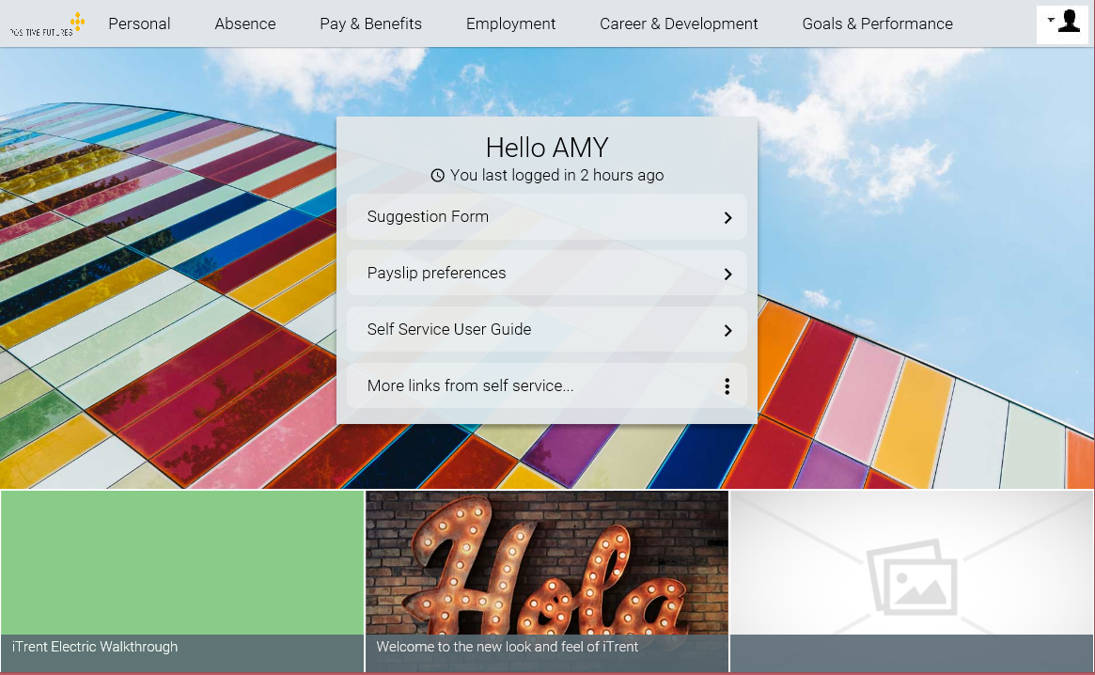

The menu bar at the top will remain on screen while you are in Self Service. It allows you to jump from one area of Self Service to another quickly and easily.

Clicking on the Positive Futures logo will take you back to the Home Screen.

1.3 Information Cards

On the menu bar click personal. This will bring up information cards. In this section of Self Service, there are cards that display the information we have about you in the system

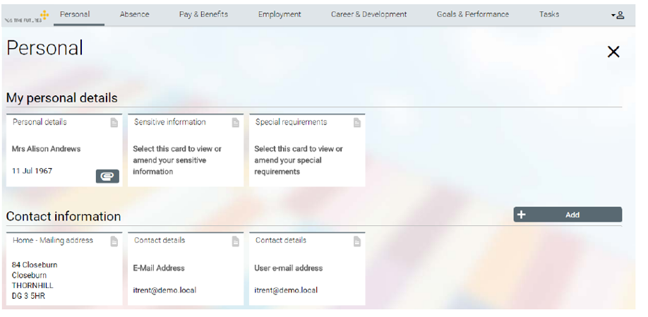

The following cards are available:
- Personal Details – view only
- Sensitive Information – view only
- Contact information – view and edit
- Emergency Contact information – view and edit
- Bank Details – view and edit
- Private vehicles – view, edit and add

Clicking on one of the cards will bring up a box with more detail and the option to review and/or edit the data within the card.

In some areas of Self Service, cards will be replaced by a list such as shown below:

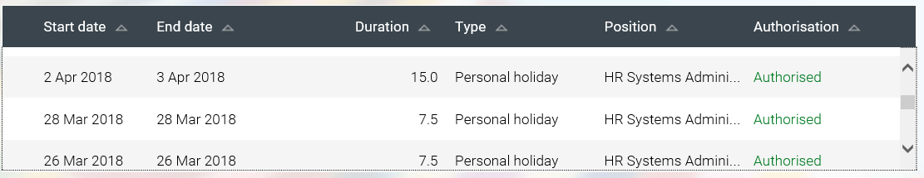

You need to click on one of the entries to bring up more detail.

1.4 Password and Memorable Information

Self Service gives you the option to change your password and to set some ‘Memorable Information’ about yourself. By setting this information, you can automatically re-set your password should you ever forget it.

Please ensure you set this information the first time you login to Self Service.

To set your memorable information, click on the person icon on the top right of the homepage:

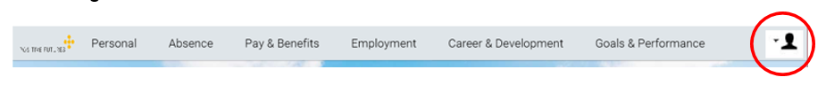

Once you have set this information you will be able to automatically reset your password or recover your username should you forget it. You can do this by clicking on the links on the sign-in box show below:

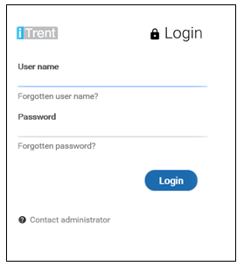

2.0 Main Menu Item: Personal

In this section of Self Service you can check that the personal details we hold against your record are correct.

In particular, please ensure that we have an up to date personal email address for you, that your emergency contacts details are current and that we have the right correspondence address for you.

2.1 Reviewing your personal details

To review your personal details, simply click on the information card you wish to update:

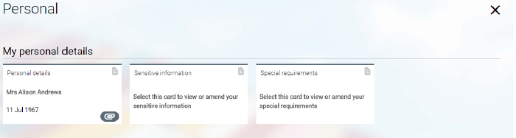

Which will bring up a box like this:  You are not able to change anything in this area as it could have impacts on your pay or tax.  If you need to change this information, you must contact HR. | 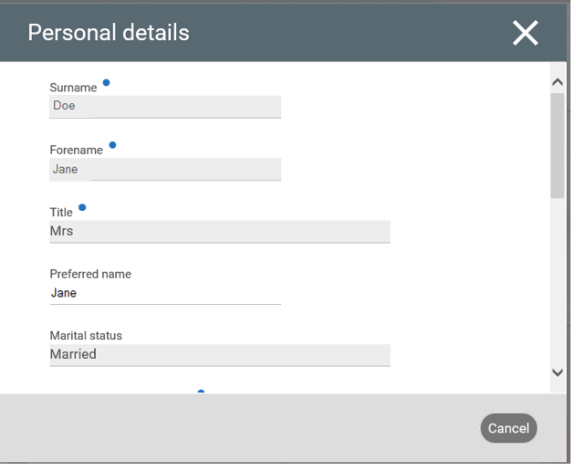

2.2 Updating your Contact Information

In Self Service you can add new contact information or amend the information we already have stored for you.

If you wish to add some new information, click on the ‘Add’ button:

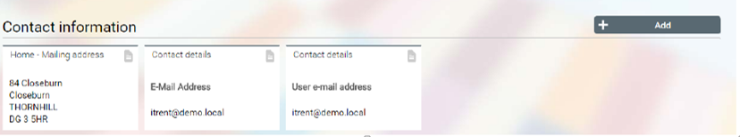

You will be asked whether you want to add an address or a contact. When you have selected a box like this will appear:  Fill out the required fields and click the ‘Save’ button when you have finished.  The new contact/address information will now be stored in iTrent.  You can modify these details at any time by clicking on the cards (as shown above) and changing the details. | 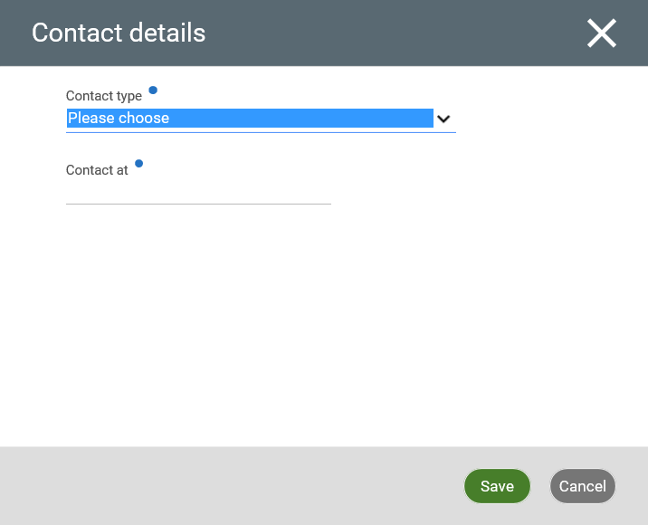

2.3 Updating your Bank Details

You can update your bank details in Self Service. These changes will take immediate effect. To amend your details, select the card as shown:

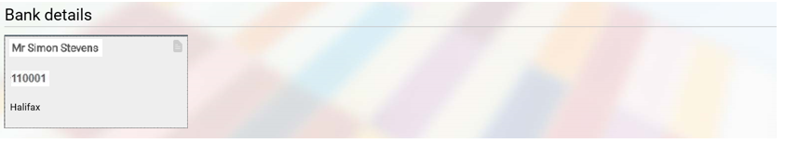

You can then update the details.

Important: Be extremely careful when making any changes to your bank details: these changes will take effect immediately and any errors could result in a delay in your pay going to your bank.

2.4 Adding Private Vehicle Details

Before submitting any claims for Mileage you need to add your vehicle details to Self Service. Once you have stored these details, they will be available for all future claims.

Log on to Self Service and select ‘Personal’ from the menu bar at the top of the page. Under ‘Private Vehicles’ click on the ‘Add Vehicle’ button as shown below:

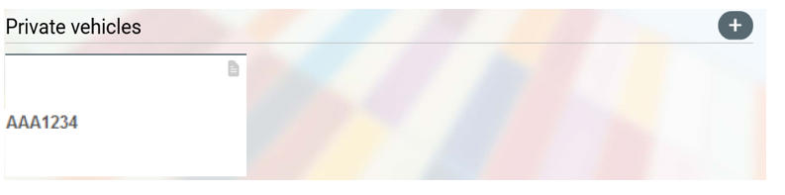

A box like this one will appear.  Ensure you fill in the following:  - Vehicle Type  - Vehicle Registration  - Start Date (you will only be able to submit mileage against this vehicle from this date)  - Engine Size  - Fuel Type  If the vehicle you are entering details for is your main vehicle, you should also tick the box ‘Default vehicle for expenses’.  When you have finished, click save. Your vehicle will now be stored against your record. | 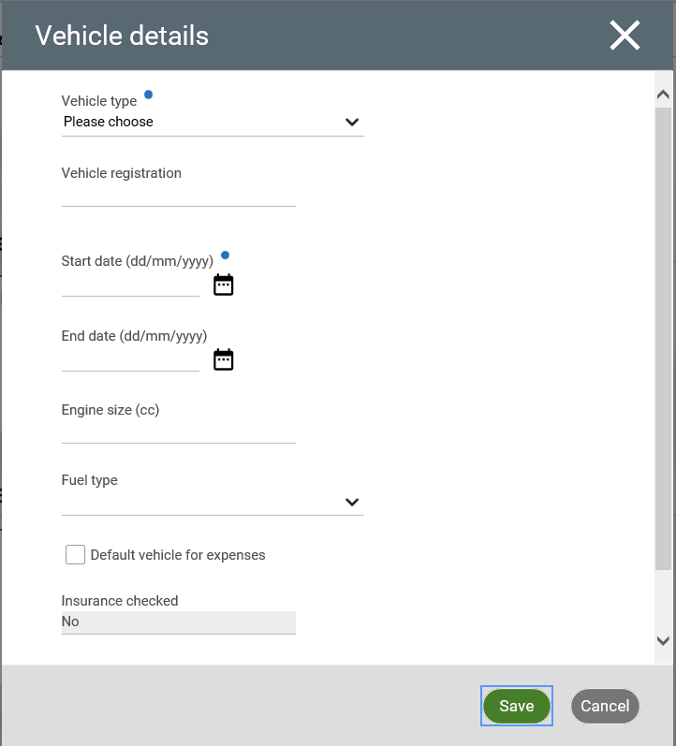

3.0 Main Menu Item: Absence

In this section of Self Service you can review the leave you have available, check when your colleagues are on holiday and book time off.

3.1 Reviewing your Holiday Balances

Click on ‘Holiday balances’ as shown below:
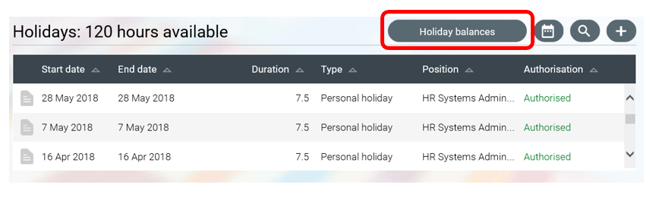

You will be shown a screen (below) that details your Annual Leave Entitlement for the year, how many hours you have already taken, how many hours you have scheduled to take and your remaining entitlement.

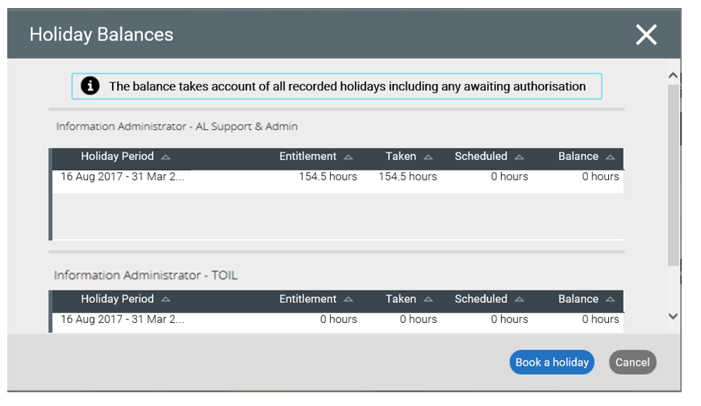

3.2 Looking at your calendar

Click on ‘My calendar’ as shown:
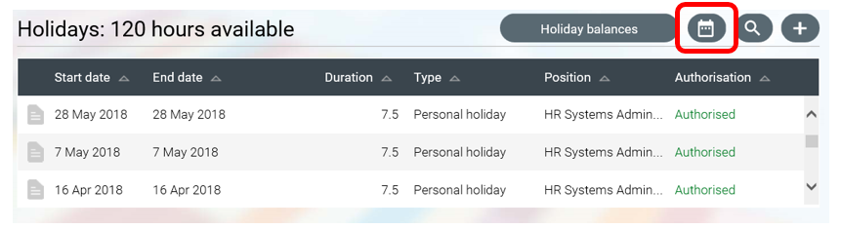

This will bring up a calendar as shown below:

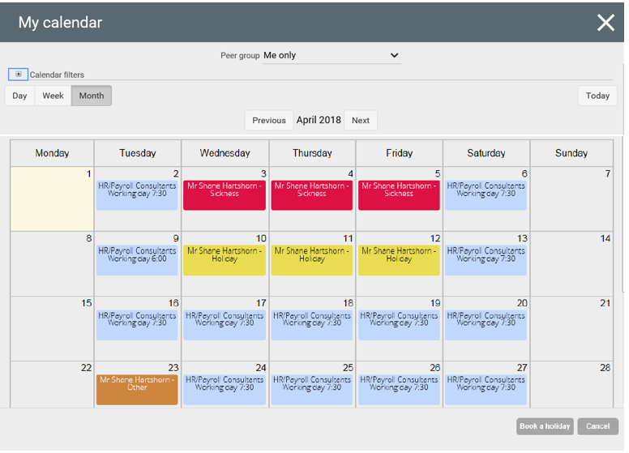

You have the option to choose whether to view your calendar in a Day, Week or Month view. Self Service defaults to a Month view.
The calendar shows your working days, your booked Holidays and any training that you are booked on.

3.3 Looking at the calendar of your colleagues

When your calendar is open, select the ‘Peer Group’ dropdown:

If this is set up for your team you will be able to select any calendars you have been assigned to.

This view should show everyone in the group and whether they have any Holidays or Training and what days they are due to be working.

3.4 Adding a new holiday

You can request a holiday in Self Service by either clicking on ‘Add holiday’:
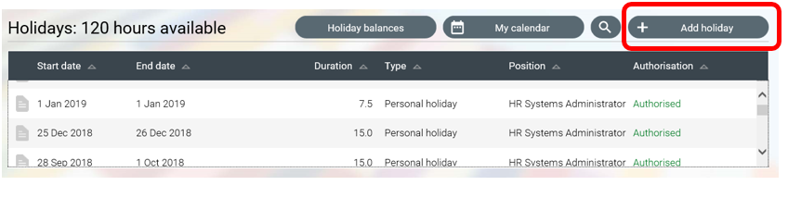

Or, when in your Calendar, clicking on ‘Book a holiday’:

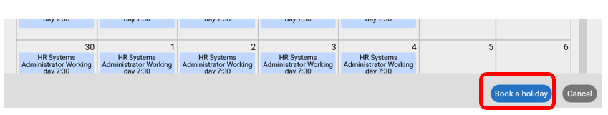

A box like this one will appear.  You will need to select your absence type and the Holiday period.  The next few pages will explain this in detail. | 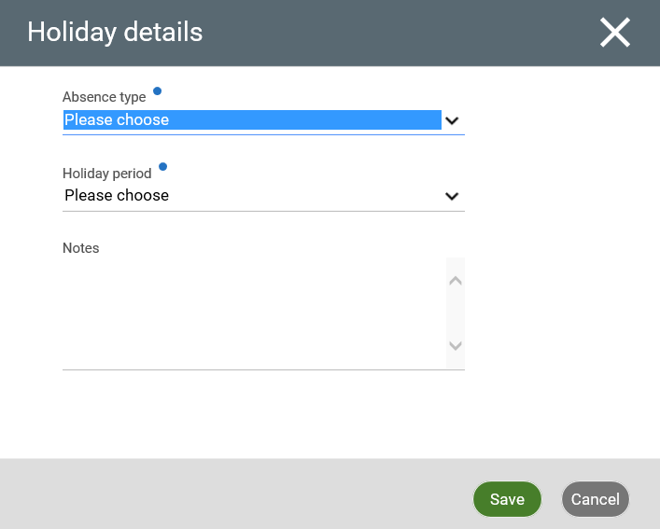

3.4.1 Requesting a single day’s holiday

- Select the ‘Absence type’. This is ‘Personal holiday’.
- Select the ‘Holiday period’ of ‘Full day’.
- A new field – ‘Start date’ – will appear. Select the date you want.
- Complete any ‘Notes’ you want to add.
- Click save.

Example:

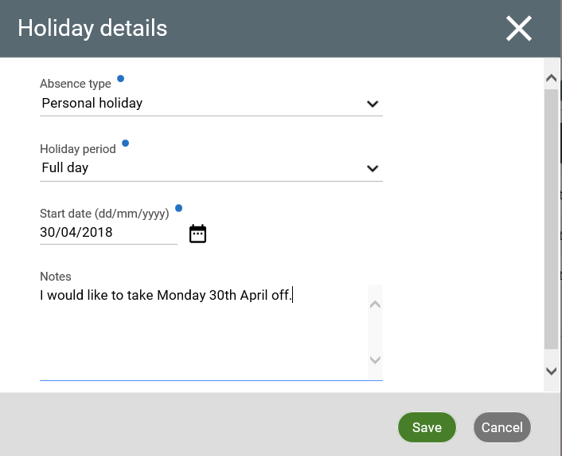

Self Service will send an email to your line manager with details of the holiday request. You will receive an email telling you the outcome.

3.4.2 Requesting more than one day’s holiday

- Select the ‘Absence type’. This is ‘Personal holiday’.
- Select the ‘Holiday period’ of ‘More than one day’.
- Complete all the new fields that appear.
- If you the start or end of your holiday is not a full day, select whether you will be away for half the day or specify the time you will be away from/to.
- Complete any ‘Notes’ you want to add.
- Click save.

Example:

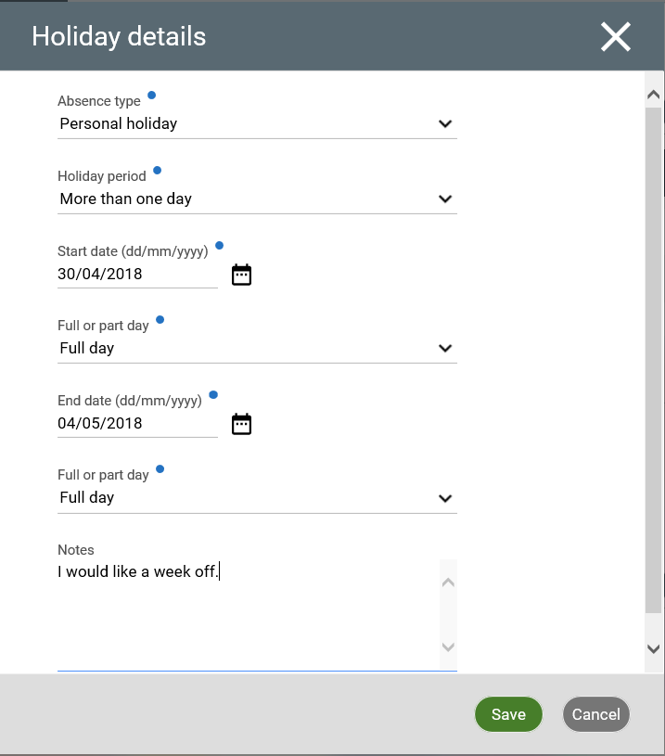

Self Service will send an email to your line manager with details of the holiday request. You will receive an email telling you the outcome.

3.4.3 Requesting part of a day as holiday

- Select the ‘Absence type’. This is ‘Personal holiday’.
- Select the ‘Holiday period’ of ‘Part day’.
- Two new fields will appear – ‘Start date’ and ‘Morning or Afternoon’.
- Select the date you want.
- Select whether you are taking the morning, afternoon or a specific time off.
- If you select ‘Specific time’, you must complete the additional fields that appear – ‘Start time’, ‘Hours absent’ and ‘End time’.
- Complete any ‘Notes’ you want to add.
- Click save.

Example:

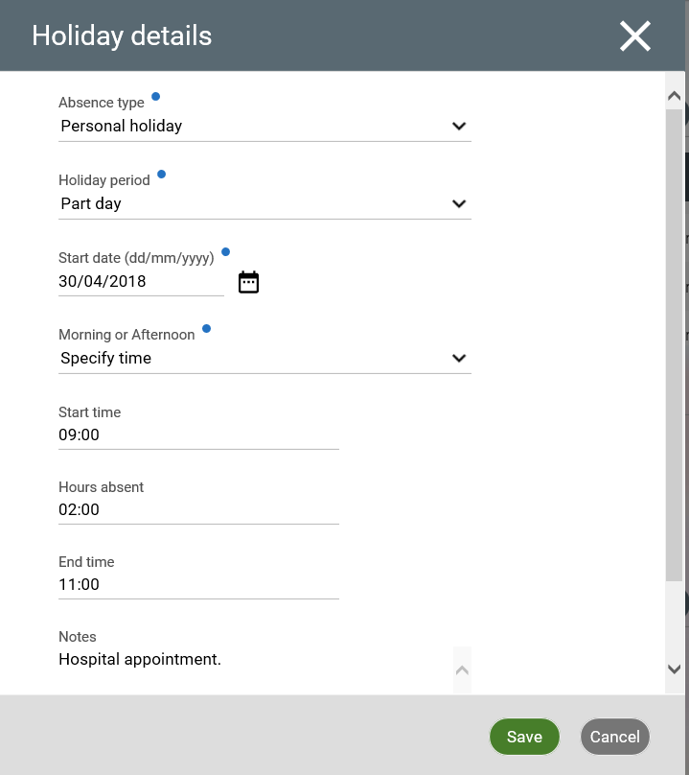

Self Service will send an email to your line manager with details of the holiday request. You will receive an email telling you the outcome.

3.5 Cancelling a Holiday

Up until a holiday request has been authorised by your Manager, you can edit or delete the request at any time by clicking on the request.

However, once a holiday has been authorised, it can only be deleted by your Manager. If you need to change/ cancel a holiday, please contact your Manager.

4.0 Main Menu Item: Pay & Benefits

In this section, you are able to see everything relating to your pay and download copies of your payslip and P60.

4.1 How to view and download your Payslip

Click on the ‘Pay & Benefits’ tab and you will see a screen like this.

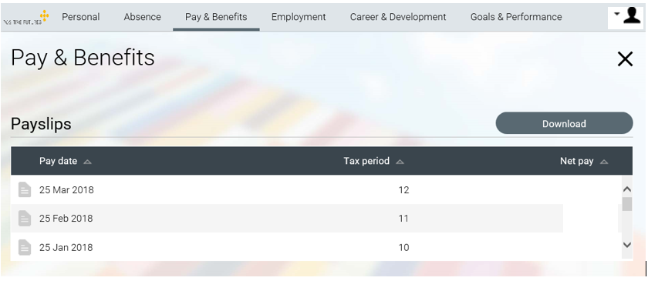

To see your payslips, click on any of the dates listed and another screen will appear like this:

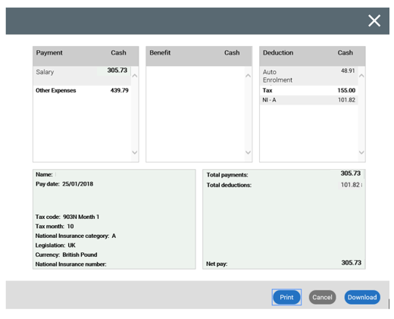

This is a simplified version of your payslip and is not comprehensive. You can download a detailed payslip by clicking on the ‘Download’ button. This will begin to download a PDF version to your computer.

4.2 How to download a PDF copy of your P60

To view your P60s, simply click on the P60 you wish to view and this will download the P60 to your computer.

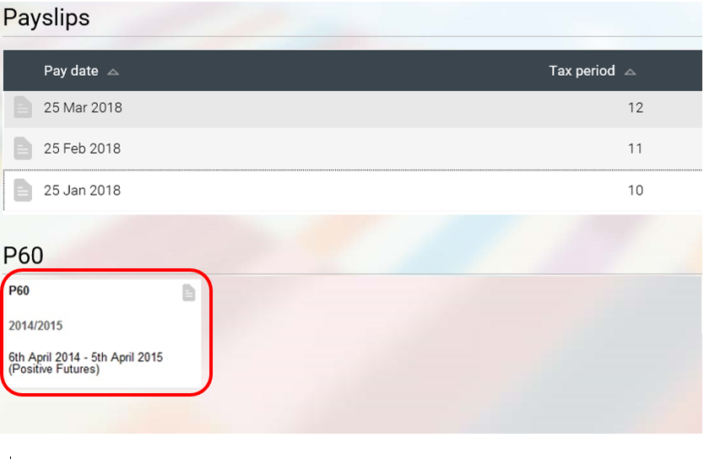

4.3 How to change the email address and / or password that your payslip and / or P60 is emailed to

On the home page of Self Service there is a quick link called ‘Payslip Preferences’:

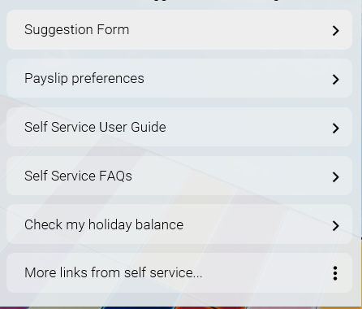

Click on the link and a box will open up allowing you to make any changes you require. Make the changes and click ‘Save’.
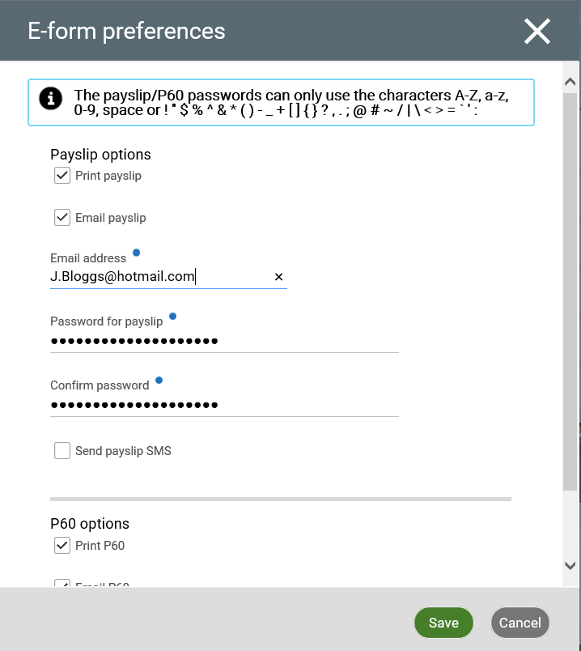

Note: This will only affect payslips issued after the changes. It will not change the password to payslips you have already received.

4.4 How to add a new Expenses Claim

This section will tell you how to create and submit a claim for expenses on Self Service.

You cannot submit an expenses claim unless you have a personal vehicle attached. Please refer to Section 2.4 of this Document for details on how to add your vehicle to Self Service.

4.4.1 Creating a new expenses claim

To add a new expenses claim, select ‘Pay & Benefits’ from the menu bar at the top of the page. Under ‘Time & Expenses’ click on ‘Add claim’ as shown below.

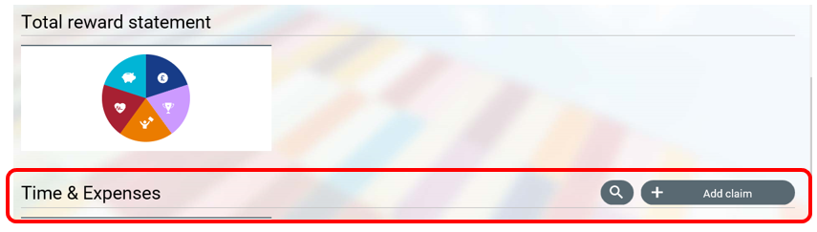

This will bring up a box as shown here:  Enter the start date of the expenses claim. This should be the 1st of the previous month. You can save each claim as draft until you are ready to submit.  Select the job title against which the expense was incurred (only required if you have more than one role). This will tell iTrent which Manager should receive the claim.  Select the claim template you need to use:  - Mileage & Other Expenses; or  - Non Mileage  Click the button ‘New’ and a new claim form will appear for you to complete. | 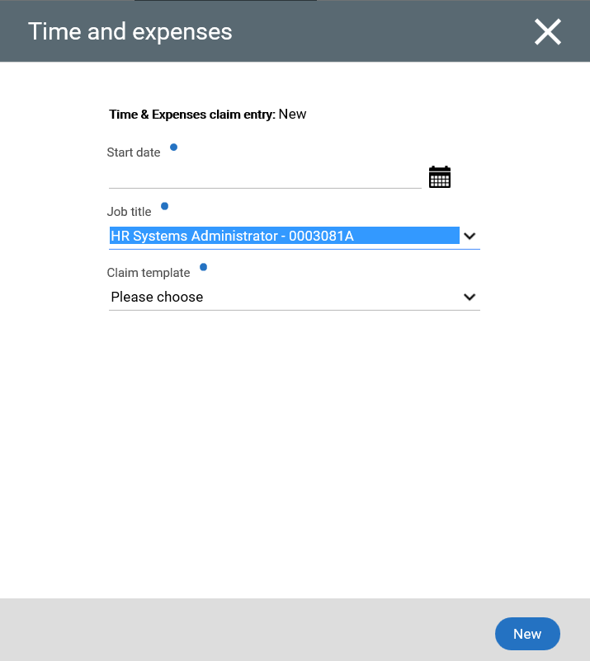

4.4.3 Entering Mileage

Your default private vehicle will be pre-selected. If you change your vehicle, you will need to change the details. Please refer to Section 2.4 of this Document for details on how to add your vehicle to Self Service.
Ensure the following fields are complete:

Journey. This is drop down selection. Your saved personal journeys will appear first and Positive Futures’ office journeys will appear below. Select the journey you need. Positive Futures’ office journeys will automatically be completed.

Date. You can either type in the date or double click in the box to bring up a calendar. | 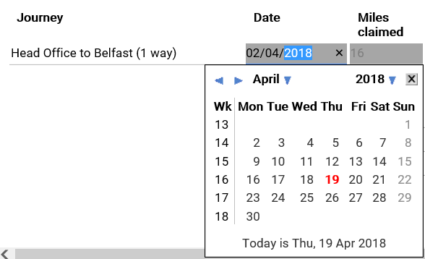

Miles claimed. If you have selected a Positive Futures’ office journey, this field will automatically complete. If you have selected a personal journey, you may need to fill this in.

Passengers. Type in a numerical value. You should enter the passenger names under ‘Names of Passengers’. If there were no passengers enter 0.

From/To. If you have selected a Positive Futures’ office journey, this field will automatically complete. If you have selected a personal journey, you will need to fill this in. Use Postcodes where possible. Keep the length of text as short as possible as too much text could stop the claim being saved, for example if you are visiting a person we support use their initials i.e. To JB house, Pick up JB or Take JB to Cinema.
When you need to add another journey to a claim, simply click the + button at the end of the row.
If you wish to remove a journey, click the – button at the end of the row.

4.4.3 Entering other expenses

You can enter expenses against either Car Parking, Public Transport or Other Expenses. Fill out each of the fields shown below:

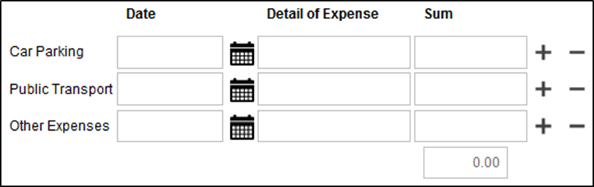

If you need to add a row, click on the + button at the end of the relevant row to bring as shown below:

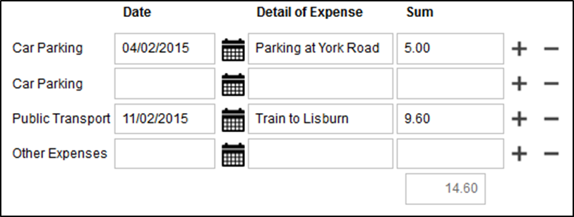

Receipts for expenses can be attached at a later stage.

4.4.4 Adding Personal Journeys to Self Service

A ‘Personal Journey’ is a business journey that is unique to you e.g. from an office to an external meeting. These can be stored in Self Service so that you can select them in the expenses claim form.

To add a Personal Journey, select ‘Pay & Benefits’ from the menu bar at the top of the page. Under ‘Saved journeys’ click on ‘Add journey’ as shown below.

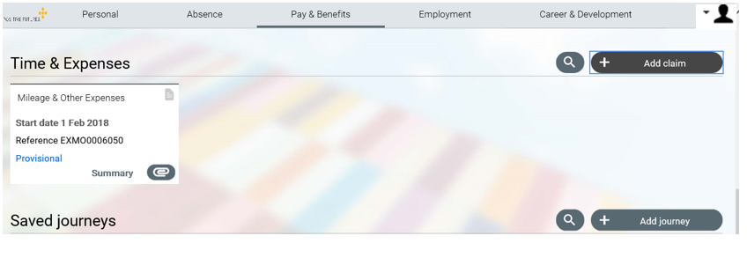

This will bring up a box as shown here:  Type in:  - Journey Name  - Journey Type (Select Personal Journey from the drop down)  - Miles Claimed (how many business miles travelled)  - Tick the ‘Active’ box  Click ‘Save’ and the journey will be stored for you to select in the claim form. | 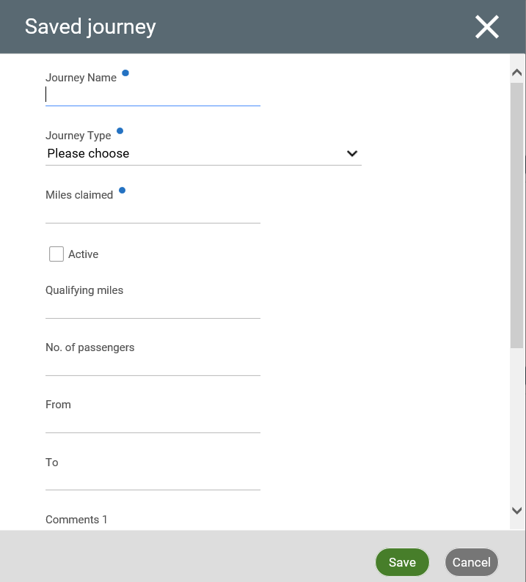

Self Service only allows you to save 20 personalised journeys. If you make a lot of “non-standard” journeys or if you have a “one off” journey that you do not wish to save as a personal journey, you can enter this as a “Misc Travel”.

To add a Misc Journey, go to Pay & Benefits, under the heading saved journeys, click add journey.

This will bring up a box as shown here:

Type in:

- Journey Name “Misc Travel”
- Journey Type (Select Personal Journey from the drop down)
- Miles Claimed enter as 0 (this can be edited when adding the claim)
- Tick the ‘Active’ box

Click ‘Save’ and the journey will be stored for you to select in the claim form.

Once you have done this, you can select this journey from the drop down as shown below:

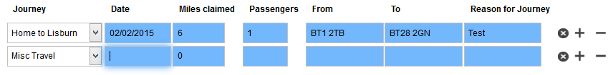

You will then need to complete the required fields. You can then edit the number of miles claimed. Please ensure details of the journey are completed in from and to, reason for journey and passenger names (if any).

NOTE: Wherever possible, you should record repeat journeys as a personal journey.

4.4.5 Saving a claim

If you wish to save your claim to review at a later stage, click save draft. If your claim has errors you will be informed. This may be because you have not completed mandatory fields.

4.4.6 Submitting your claim

When you have completed your expenses for the month, click on the ‘Submit’ button. You should see this screen:

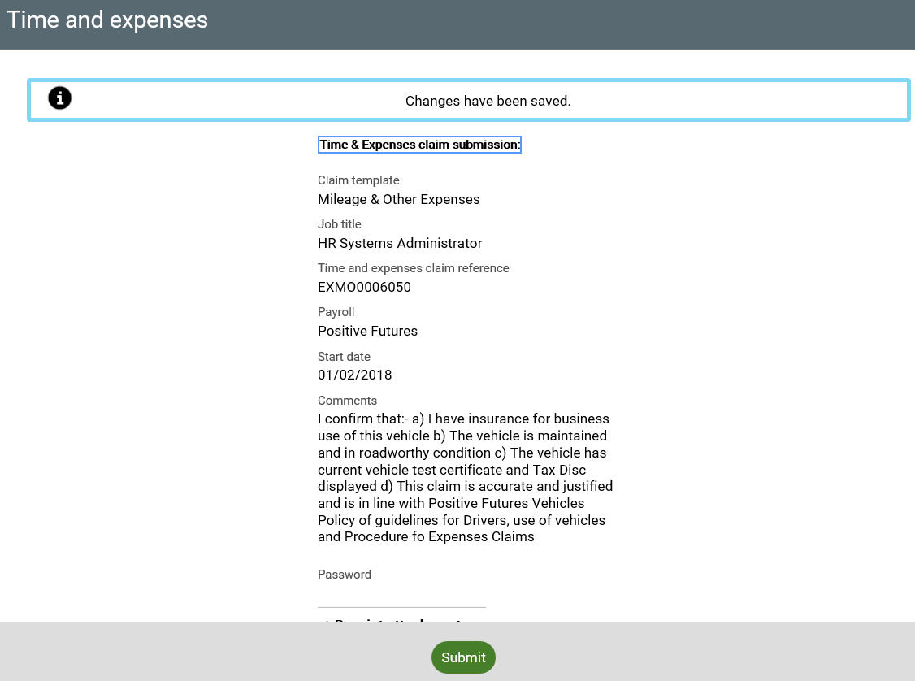

If you have any receipts to attach, click on ‘+ Receipt attachments’ and attach the receipts. To attach the receipt, select expenses receipt from receipt type. You will need to scan or photograph the receipt and save to a folder where you can upload from. Select the file, click open then submit.

To submit your form to your line manager for approval, fill in your password and click on ‘Submit’. The form will now be submitted to your manager and you will receive a confirmation email.

4.4.7 Reviewing your claims

The claim form can be reviewed at any time in Self Service by navigating to ‘Time & Expenses’:

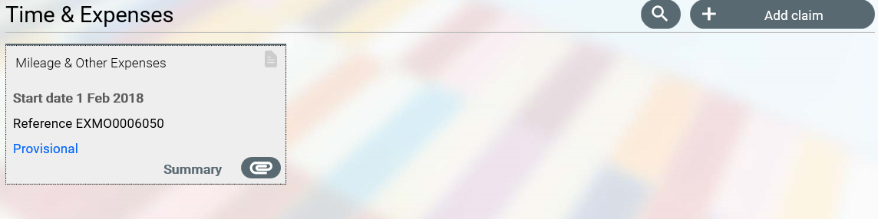

Clicking on ‘Summary’ will bring up a box like the one shown here:  This is a summary of the provisional amount you have claimed.  4.4.8 Authorisation  When your claim has been reviewed you will receive an email notification of the outcome and, if authorised, notification of when the claim will be paid. | 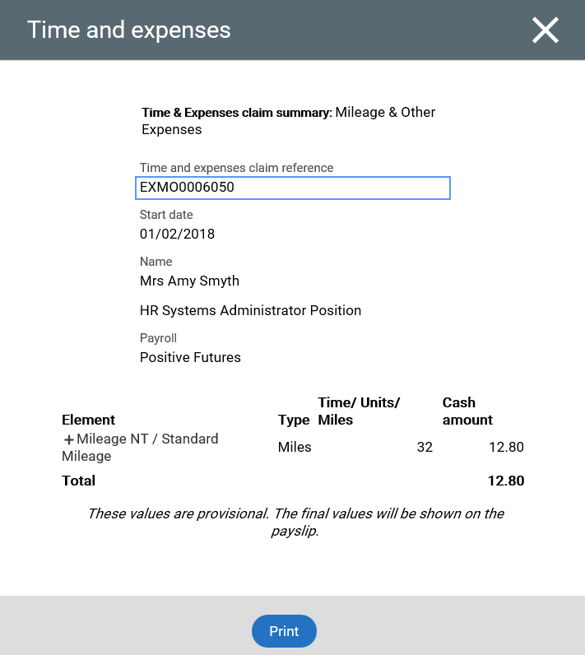

Note on Qualifying Miles

Travel mileage is measured from the normal work base. If staff are claiming for an all-day course and do not travel to the normal work base, claims must be made based on the mileage measured from home less the mileage normally driven to work. Staff travelling from the normal work base via other offices or meeting places, finally travelling home without returning to the normal work base, may only claim the difference between the total journey and the mileage normally driven to or from work.

5.0 Main Menu Item: Employment

5.1 How to review your employment details

This section will provide you with details of your employment with Positive Futures. The main screen shows a summary card like this:

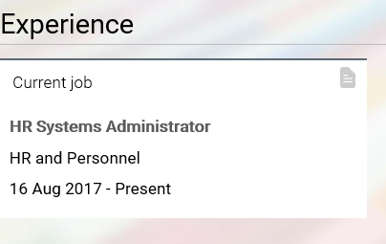

Clicking on this card will bring up more detail as the example below shows:

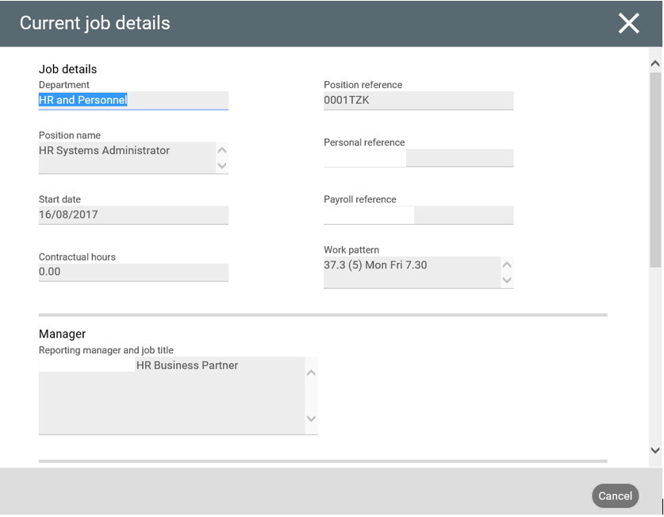

6.0 Main Menu Item: Career & Development

Within this section of Self Service you can review the training records we have for you, record a Personal Learning Event, check what Qualifications and Memberships we have recorded against you and tell us about any new ones you may have.

6.1 How to review the training we have recorded against you

All the training we have recorded for you is listed under Learning Activities. You can filter this list by using the drop down selection:

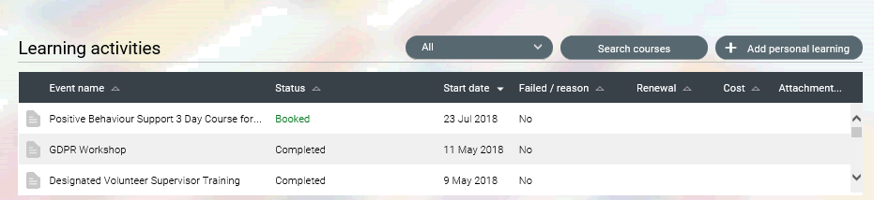

Clicking on the Career and Development tab brings up a page like this:

